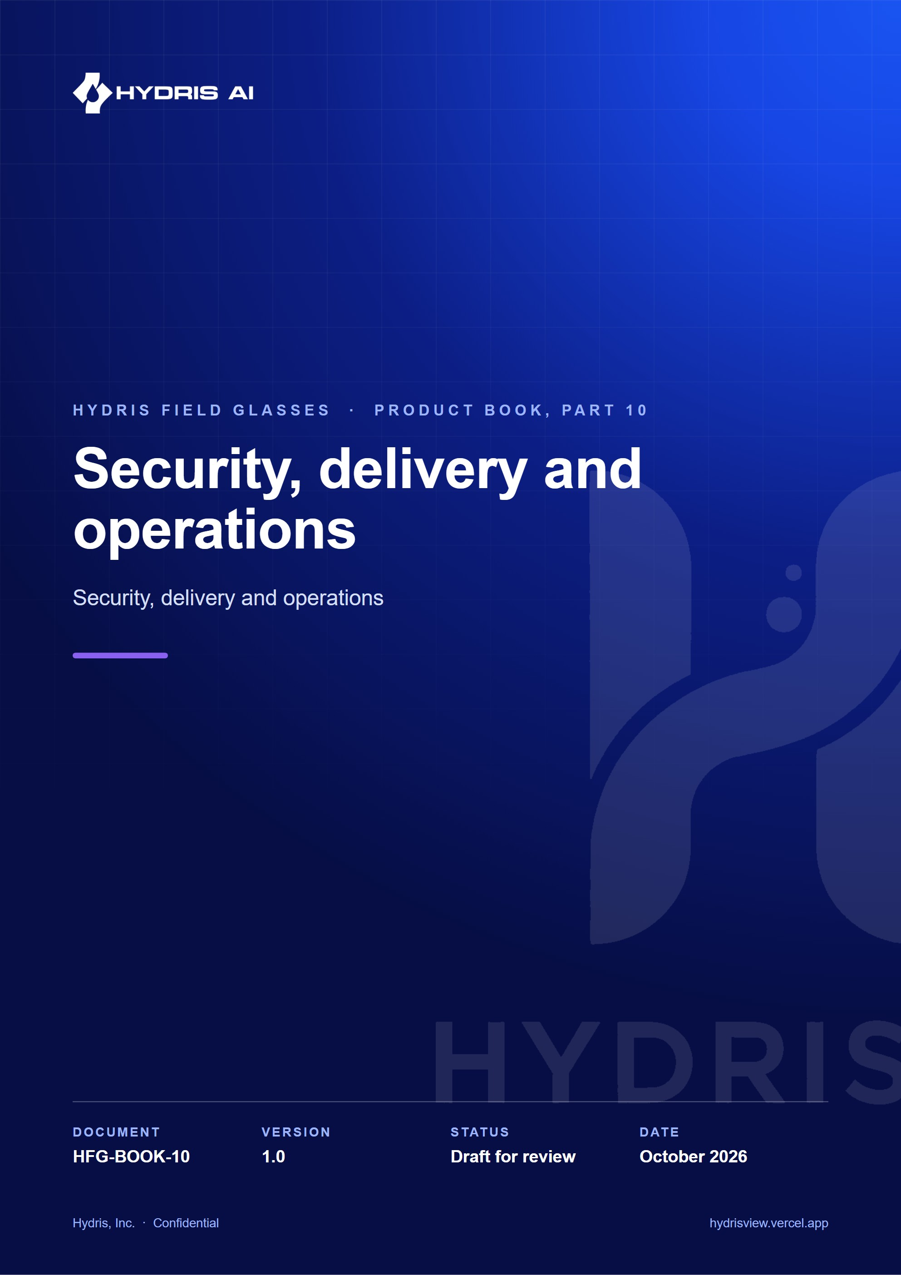
Document control
Document | Security, delivery and operations (HFG-BOOK-10)
Version | 1.0
Status | Draft for review
Owner | Product and engineering, Hydris
Audience | Leadership, product, engineering, design, partners and pilot customers
Product | Hydris Field Glasses: website, operator console, glasses app, Android app, API
Source of truth | docs/product/_part10.md in tarun-km/hydrisview (this Word file is generated from it)
Classification | Confidential: Hydris, Inc. and named partners
Revision history
Version | Date | Author | Changes
1.0 | October 2026 | Product and engineering, Hydris | First edition

Contents
1 Security, delivery and operations 4
1.1 Security model 4
1.2 Compliance mapping 6
1.3 Deployment topologies 6
1.4 Quality 8
1.5 Operations 9
1.6 Known gaps register 11

1 Security, delivery and operations
Hydris puts cameras on workers' faces and turns plant readings into regulated records. Trust is therefore part of the product, not a layer on top. This part covers how Hydris protects customers and workers, how it maps to the frameworks buyers ask about, where it runs, how quality is proven, and how a customer is onboarded and supported. Every target is labelled as a target; nothing here is a certification.
3  layers of access control  RBAC, site scope, Postgres RLS |  | 15 min  access token lifetime  rotating refresh with reuse detection |  | 0  write paths to plant control  read-only to PLC, SCADA and DCS |  | 2  people per approved record  verifier and a different approver

1.1 Security model
Eight principles shape every design choice: read-only to the plant; defence in depth for tenancy; records are evidence (append-only trails); least privilege for devices; secrets never stored in the clear; AI assists, people decide; capture on intent only; privacy by default.

Trust boundaries
A trust boundary is anywhere data crosses between a party or runtime Hydris controls and one it does not. Five boundaries matter.
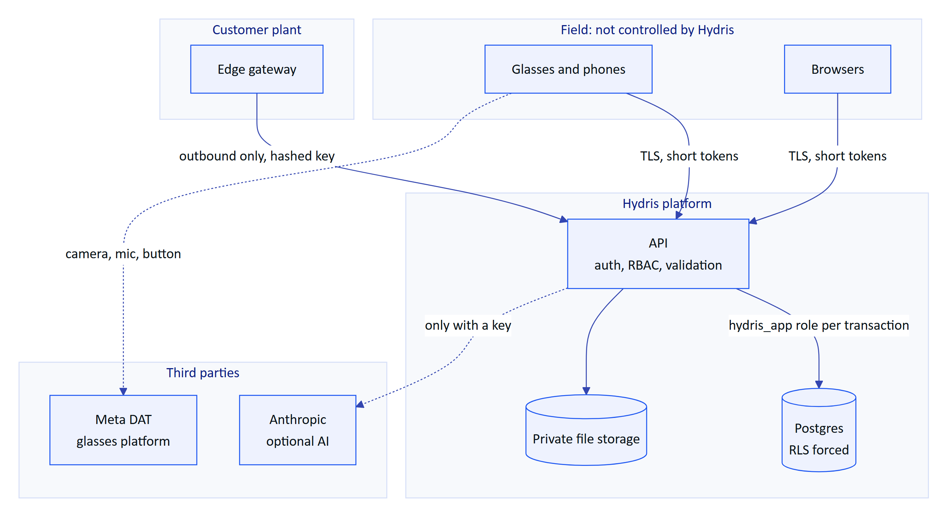
Figure 1. Trust boundaries. Data crosses five boundaries, each with its own controls.
Table 1. Top threats and controls (STRIDE extract from SECURITY_PRIVACY.md)
Threat | Scenario | Control in the product | Open gap
Spoofing | Password guessing, credential stuffing | argon2id, lockout after 5 failures, 10 sign-ins per min, optional TOTP | No SSO, MFA not enforceable per org
Spoofing | Rogue device pairs into an org | Signed-in approver with device.pair, 300 s single-use code, hashed poll secret | No device attestation
Tampering | Silent edit of readings or records | Append-only corrections and audit events at the grant level | No signed export or hash chain
Information disclosure | Cross-tenant read | RLS forced, 404 for out-of-scope records | Owner connection would bypass RLS
Information disclosure | Stolen phone | Keystore AES-256-GCM on Android, device revoke | Web glasses keep the token in localStorage
Denial of service | Login or ingest floods | Rate limits, 500 readings per call, body limits | Limits are per instance
Elevation | Device calls admin endpoints | Fixed device permission ceiling; verify and approve need a person | None known
AI | Prompt injection in a scanned page | Strict output schema, OCR cross-check, human review | No injection classifier

Privacy for camera glasses and workers
The camera only runs when a person asks for it, and only the final page leaves the phone.
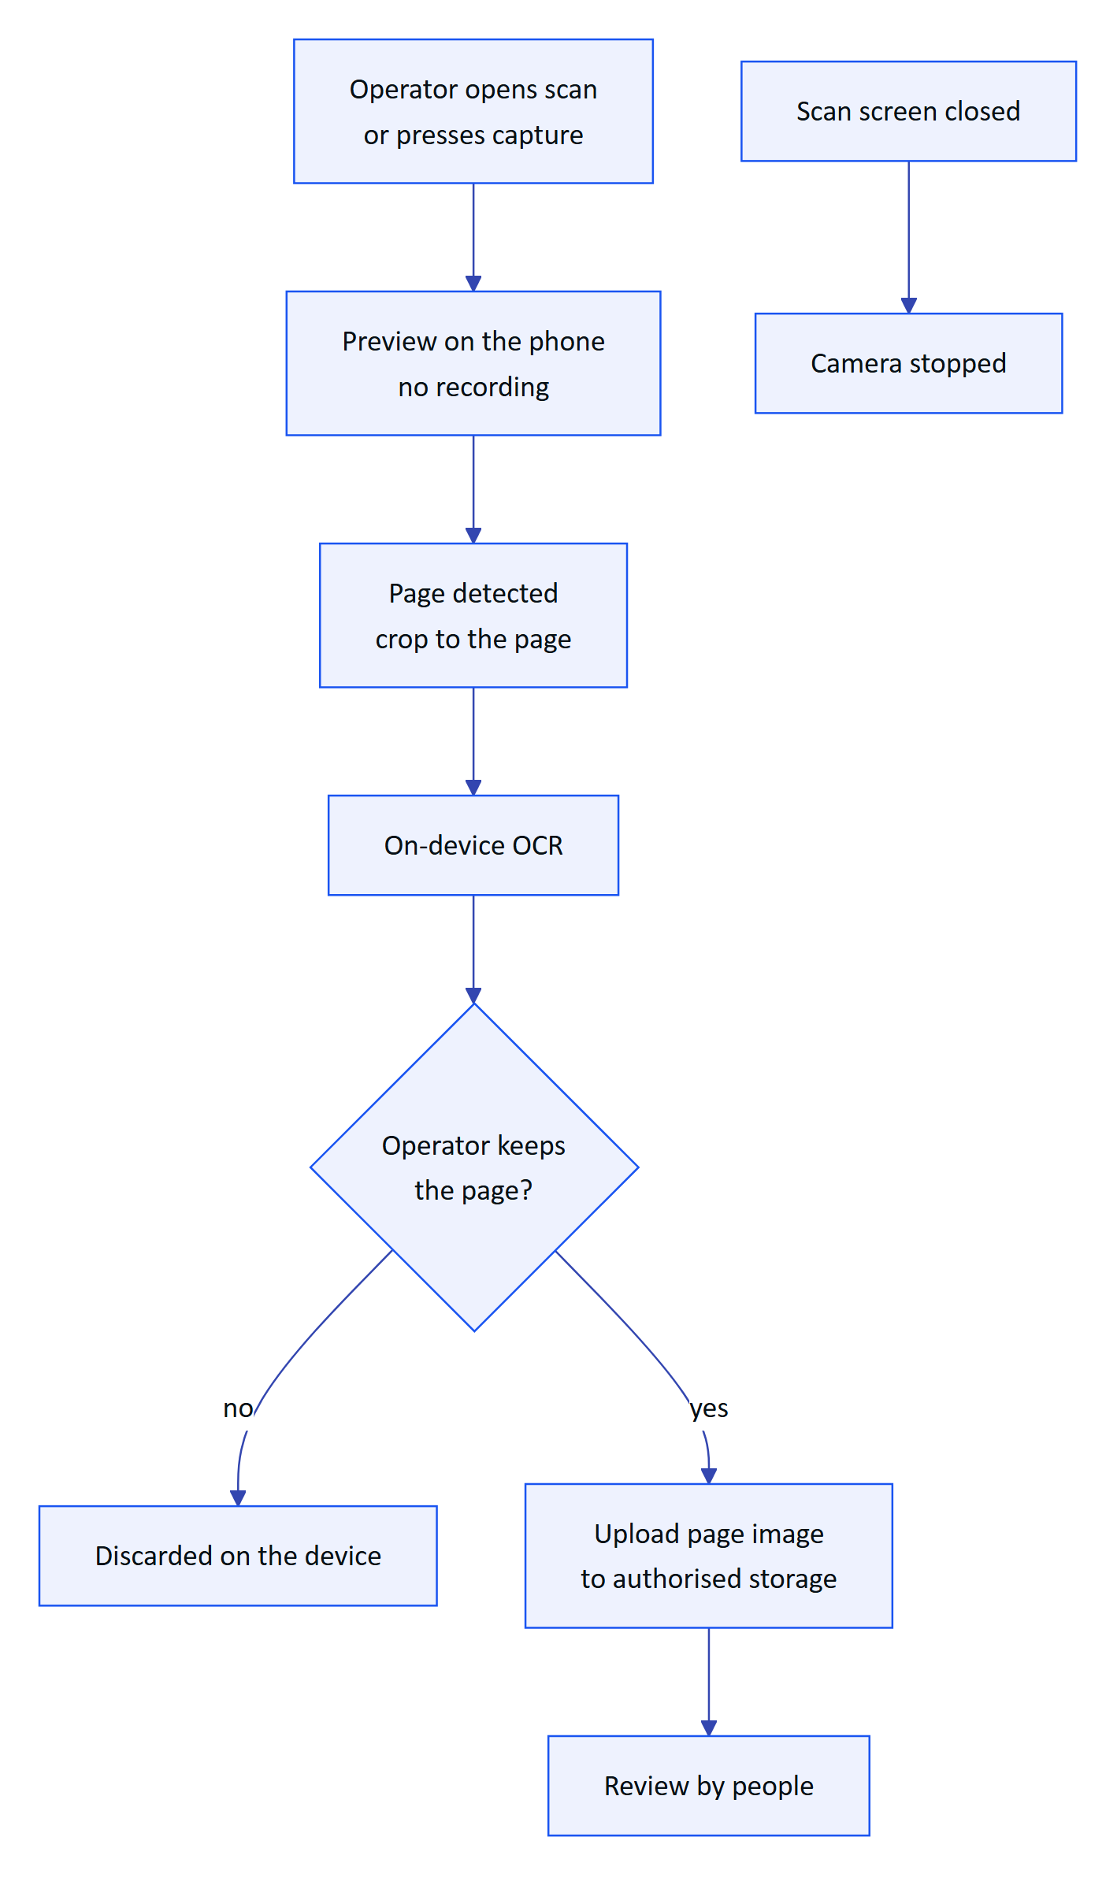
Figure 2. Camera on intent. Preview frames stay on the phone; only a reviewed page image is uploaded.
Table 2. Camera and worker commitments
Commitment | Status
No background or continuous recording, no video stored | Built
Only text after "Hey Hydris" is sent; audio never uploaded to Hydris | Built
Meta capture LED cannot be disabled by apps | Vendor control
No location tracking, no keystroke or gaze analytics, no individual performance reports | Built (by design)
Face and badge redaction before upload | Planned
Camera-free zones per site | Planned

1.2 Compliance mapping
The table maps frameworks to product controls. It is a mapping and a set of targets, never a claim of certification.
Table 3. Compliance mapping (targets, not certifications)
Framework | What it asks | Hydris controls | Position
India DPDP Act 2023 and Rules 2025 | Notice, safeguards, breach notice, erasure, retention limits | Encryption, RLS, audit trail, consent version on inquiries | Partial; retention and rights tooling planned
CPCB and SPCB consent conditions | Unaltered, retrievable monitoring records | Provenance, append-only corrections, freshness, CSV export | Mapping; Hydris is not the regulatory feed
CERT-In Directions 2022 | 6-hour incident reporting, 180-day logs in India | Incident plan; India log drain planned | Target
ISO/IEC 27001:2022 | ISMS and Annex A controls | Many technical controls in code | Target: ISMS build 2027
IEC 62443 | Zones and conduits, secure development | Read-only, outbound-only conduit from the DMZ gateway | Mapping; 4-1 practices as target
SOC 2 | Security, availability, confidentiality | Same controls | Target: Type I after first commercial year

Retention today is indefinite for records, with only realtime events pruned after a day. The recommended defaults (for example audit trails at least 7 years, sessions purged 30 days after expiry) are configurable per organization and Planned.

1.3 Deployment topologies
The same code runs in four shapes. A customer chooses by residency, network rules and operations appetite.
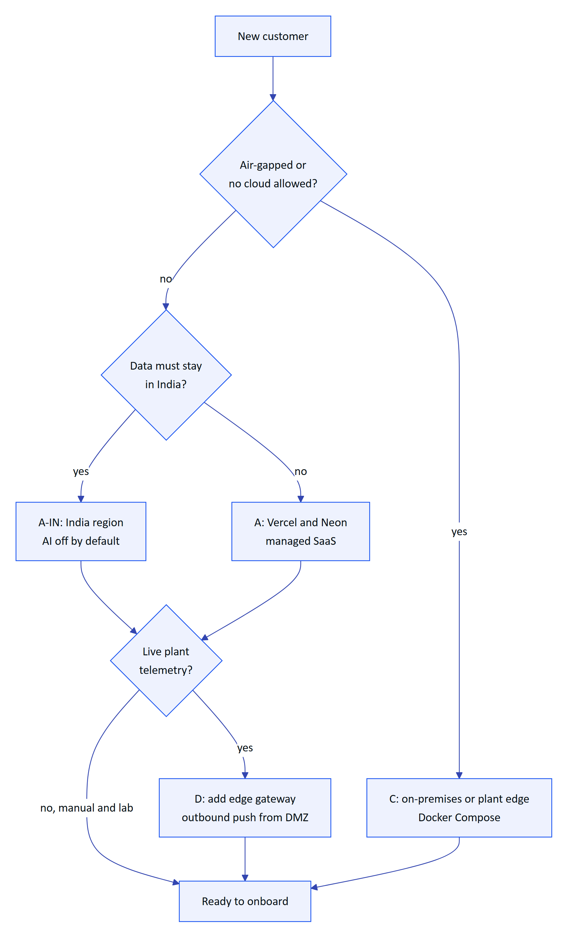
Figure 3. Topology selection for a new customer
Table 4. Topologies
Topology | Shape | Status
A, managed SaaS | Vercel functions, Neon Postgres, private Blob | Built (live as demo); production Planned
A-IN, India region | Mumbai functions, Indian database and S3, India log drain, AI off unless an addendum is signed | Planned
B, container API | Vercel web, API container next to managed Postgres | Partial (render.yaml)
C, plant edge | Postgres 17, API and web on one plant server | Built (docker-compose.yml)
D, hybrid gateway | A or A-IN plus an edge gateway pushing over HTTPS | API Built; gateway Planned

Table 5. Environment matrix
Environment | Purpose | Database | Status
dev | Local development | PGlite on disk | Built
preview | One per pull request | Neon branch (target) or demo mode | Partial
staging | Release candidate, hardware tests, pilot rehearsal | Neon staging branch | Planned
prod | Customer tenants | Neon production, region pinned, point-in-time recovery | Planned
demo | Public sales demo | In-memory PGlite per instance, public secrets | Built

Release pipeline
Today there is no CI: a push to main deploys through Vercel's Git integration, and tests are run by developers. Migrations run on cold start under an advisory lock. The proposed pipeline gates every pull request and every release tag.
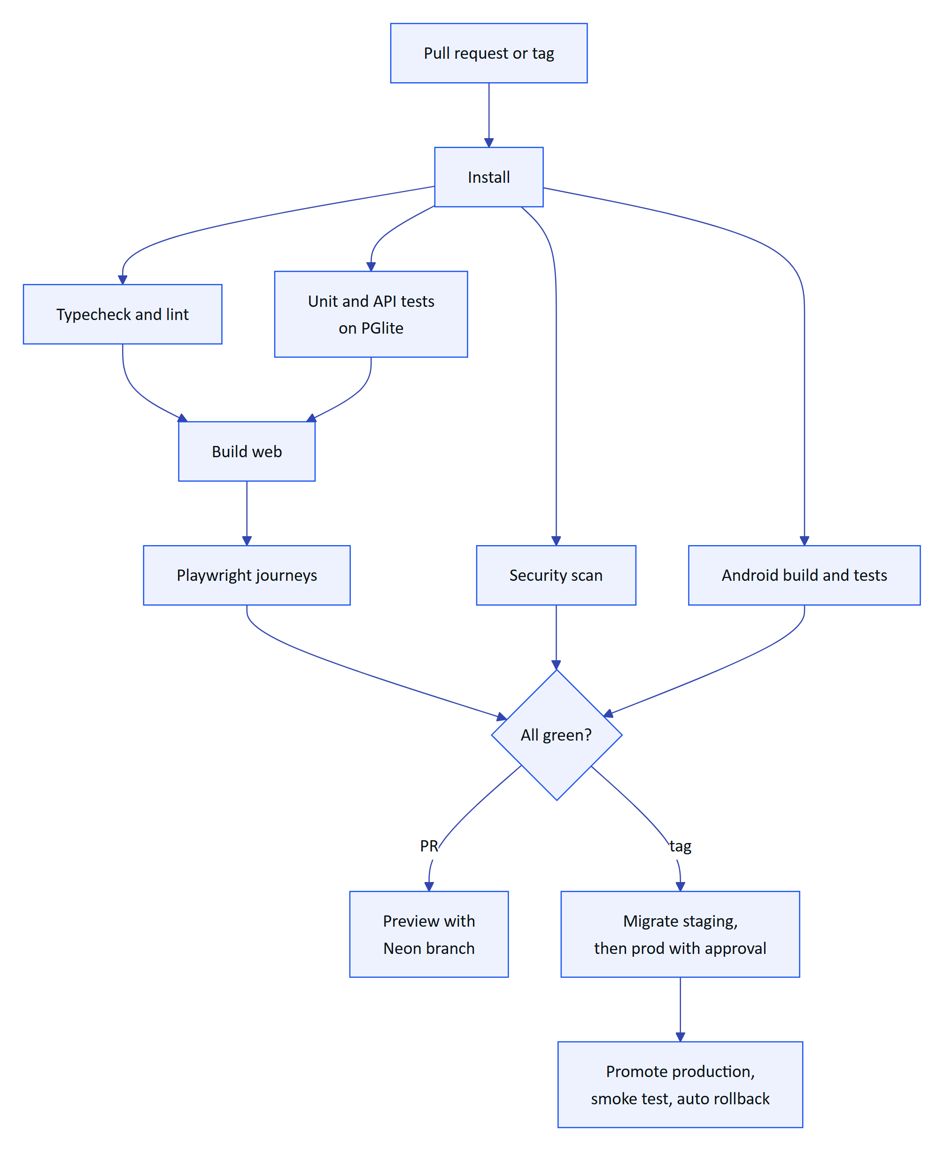
Figure 4. Proposed CI and release pipeline (Planned)
DECISION
Demo and production split into two Vercel projects on the same repository: demo tracks main with no database, production deploys only on release tags after the staging gate (DEP-11).

1.4 Quality
Hydris tests from fast, deterministic checks at the base up to field trials at a plant.
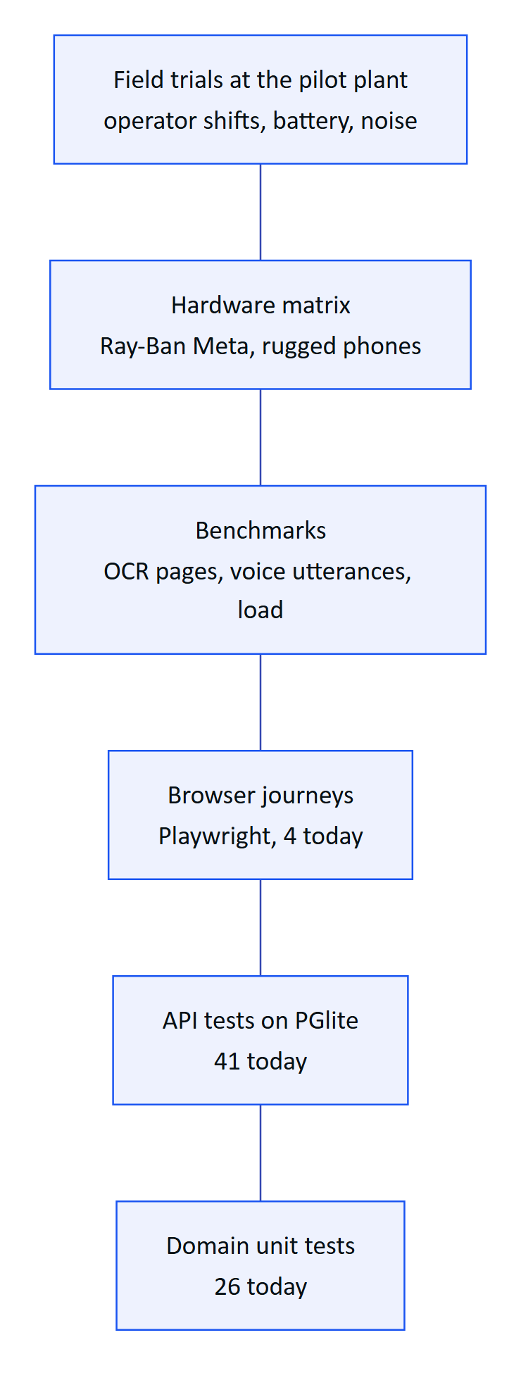
Figure 5. Test pyramid, from fast deterministic tests to field trials
The 67 domain and API tests pass (22 October 2026). They cover the security-critical paths: tenant isolation at the database, four-eyes approval, refresh reuse, pairing, alarm hysteresis and the db realtime mode. The four Playwright journeys were not re-run for this edition. The Android app has no automated tests yet and was verified by hand on a Pixel 7 emulator.

OCR and voice accuracy design
Accuracy is measured with benchmarks, all targets for the first pilot.
Table 6. Benchmark design (targets)
Benchmark | Set | Primary metric | Target
OCR | 120 pages: printed lab reports, filled templates, handwritten logbooks, tables, degraded captures; ground truth keyed twice | Silent error rate (wrong but marked as matching) | Under 0.5 %
OCR | Same | Field accuracy | 90 % printed, 75 % handwritten
Voice | 600 utterances by at least 6 speakers in quiet, 65 and 85 dB(A) | Hallucinated numbers | 0
Voice | Same, including 40 unsafe action requests | Unsafe compliance | 0
Voice | 8 hours of plant conversation | Wake false accepts | Under 1 per hour

DECISION
The silent error rate is the primary OCR metric. A system that is 85 % accurate and flags what it is unsure of is safer than one that is 95 % accurate and confidently wrong on the rest.

Release gates and pilot exit
Table 7. Release gates
Gate | Criteria
1, pull request | Typecheck and tests green; new behaviour has tests
2, main | Build, Playwright, accessibility and dependency audit clean
3, release candidate | OCR and voice benchmarks in tolerance; load and security scans clean
4, pilot readiness | Hardware rows H1 and H5 passed; zero open S1 and S2 defects; signed review

Pilot exit criteria, as of today:
- ☑ Domain and API suites pass (67 of 67)
- ☑ Tenant isolation proven at the database boundary
- ☑ Four-eyes approval enforced outside demo tenants
- ☐ CI running gates 1 and 2 on every pull request
- ☐ Email transport wired for invitations and resets
- ☐ Stale-data rules running every minute on Vercel
- ☐ OCR and voice benchmarks run within targets
- ☐ Hardware rows passed on Ray-Ban Meta and a rugged phone
- ☐ External penetration test with no open high findings

1.5 Operations

Customer onboarding
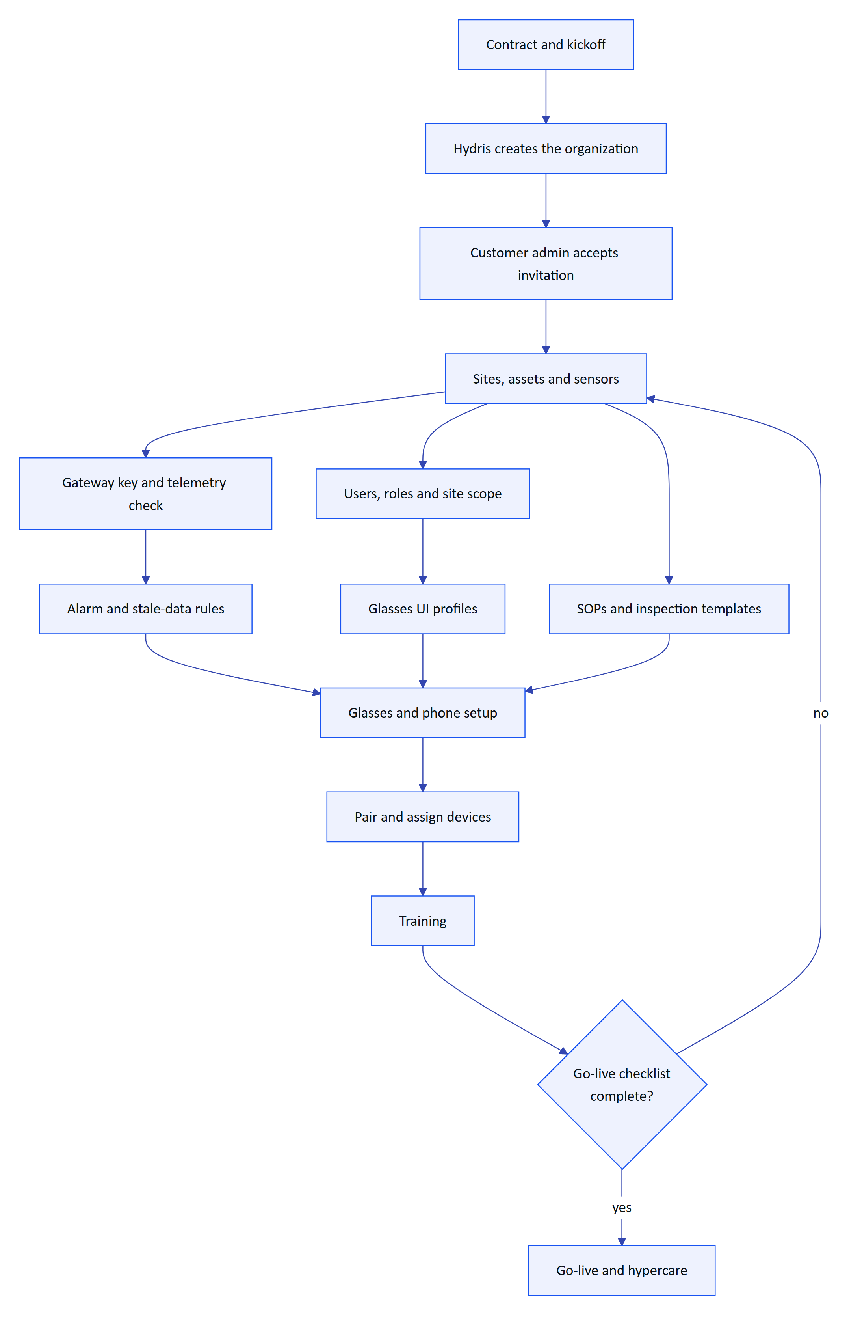
Figure 6. Customer onboarding from organization creation to go-live
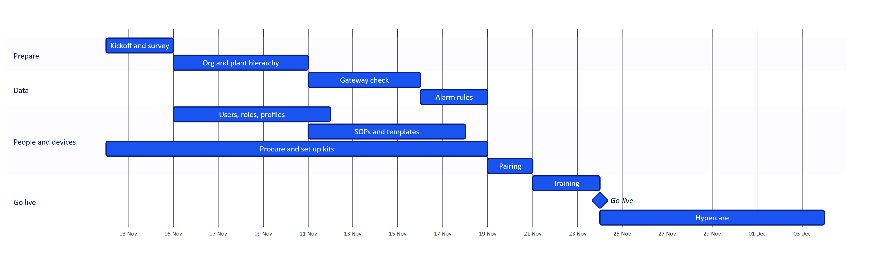
Figure 7. Typical six-week pilot for one plant with up to ten operators (plan, not a commitment)

Support and incidents
Operators go to their supervisor, the supervisor to the customer admin, and the customer admin to Hydris.
Table 8. Support tiers
Tier | Handles
Customer admin | First line inside the plant: users, pairing, profiles
Hydris L1 | Anything a documented runbook procedure resolves
Hydris L2 | Configuration, logs and platform-admin actions
Hydris L3 | Code, data and infrastructure; postmortem for Sev 1 and 2

Table 9. Incident severity (targets)
Severity | Definition | Response | Customer update
Sev 1 | Platform down or data at risk, including any suspected breach | L3 within 15 min | Within 1 hour, then hourly
Sev 2 | Major function down, no workaround | L3 within 1 hour | Within 2 hours, then every 4 hours
Sev 3 | Degraded, workaround exists | Next business day | Daily
Sev 4 | Minor or cosmetic | Planned release | On release

A suspected breach also triggers external notices: customers within 24 hours, CERT-In within 6 hours for reportable incidents, and the DPDP Board and data principals as the Rules require.

Operations KPIs
5 min  time to pair  target, median |  | 1 day  scan to verified  target, median |  | 5 min  critical alarm acknowledge  target, median |  | 99.5 %  monthly availability  target

Table 10. Operations KPIs (targets) and where they are measured
KPI | Target | Source in the product
Pairing success on first code | Over 90 % | Completed vs expired challenges
Verified to approved | Median 2 business days | Audit document timestamps
Rescan rate | Under 10 % | Rejected vs total documents
Alarms resolved with a note | 100 % (enforced in code) | Resolve transition
Sensors live | Over 98 % of sensor-hours | Freshness history
Devices connected on shift | Over 95 % | Device report

1.6 Known gaps register
The gaps below are drawn from the security, deployment and architecture registers. Each has an owner and a plan; the quadrant shows how they compare.
Table 11. Known gaps that matter before pilot and GA
ID | Gap | Impact | Priority
DEP-01 | No CI pipeline | Regressions and unsafe migrations can reach production | High
DEP-02 | Cron runs daily on Vercel | Stale-data alarms up to 24 h late | High
DEP-03 | Android release signed with the debug key | Cannot distribute through Play | High
DEP-04 | Email not wired | Invitations and resets need manual delivery | High
DEP-05 | No metrics, tracing or alerting | Incidents found by users | High
DEP-11 | Demo and production share one project | Customer data could land in a demo | High
SEC | Owner connection runs the application | RLS bypass if a query escapes the tenant role | High
SEC-03 | Web glasses keep the device token in localStorage | Token exposed to scripts on the origin | Medium
DEP-10 | Per-instance rate limiting | Weaker limits under many instances | Medium
DEP-06 | Audit page images in Postgres | Database and backup growth | Medium
DEP-07 | No retention or purge jobs | Unbounded growth; DPDP retention limits | Medium
TD-12 | No content security policy | Weaker defence against injected scripts | Medium

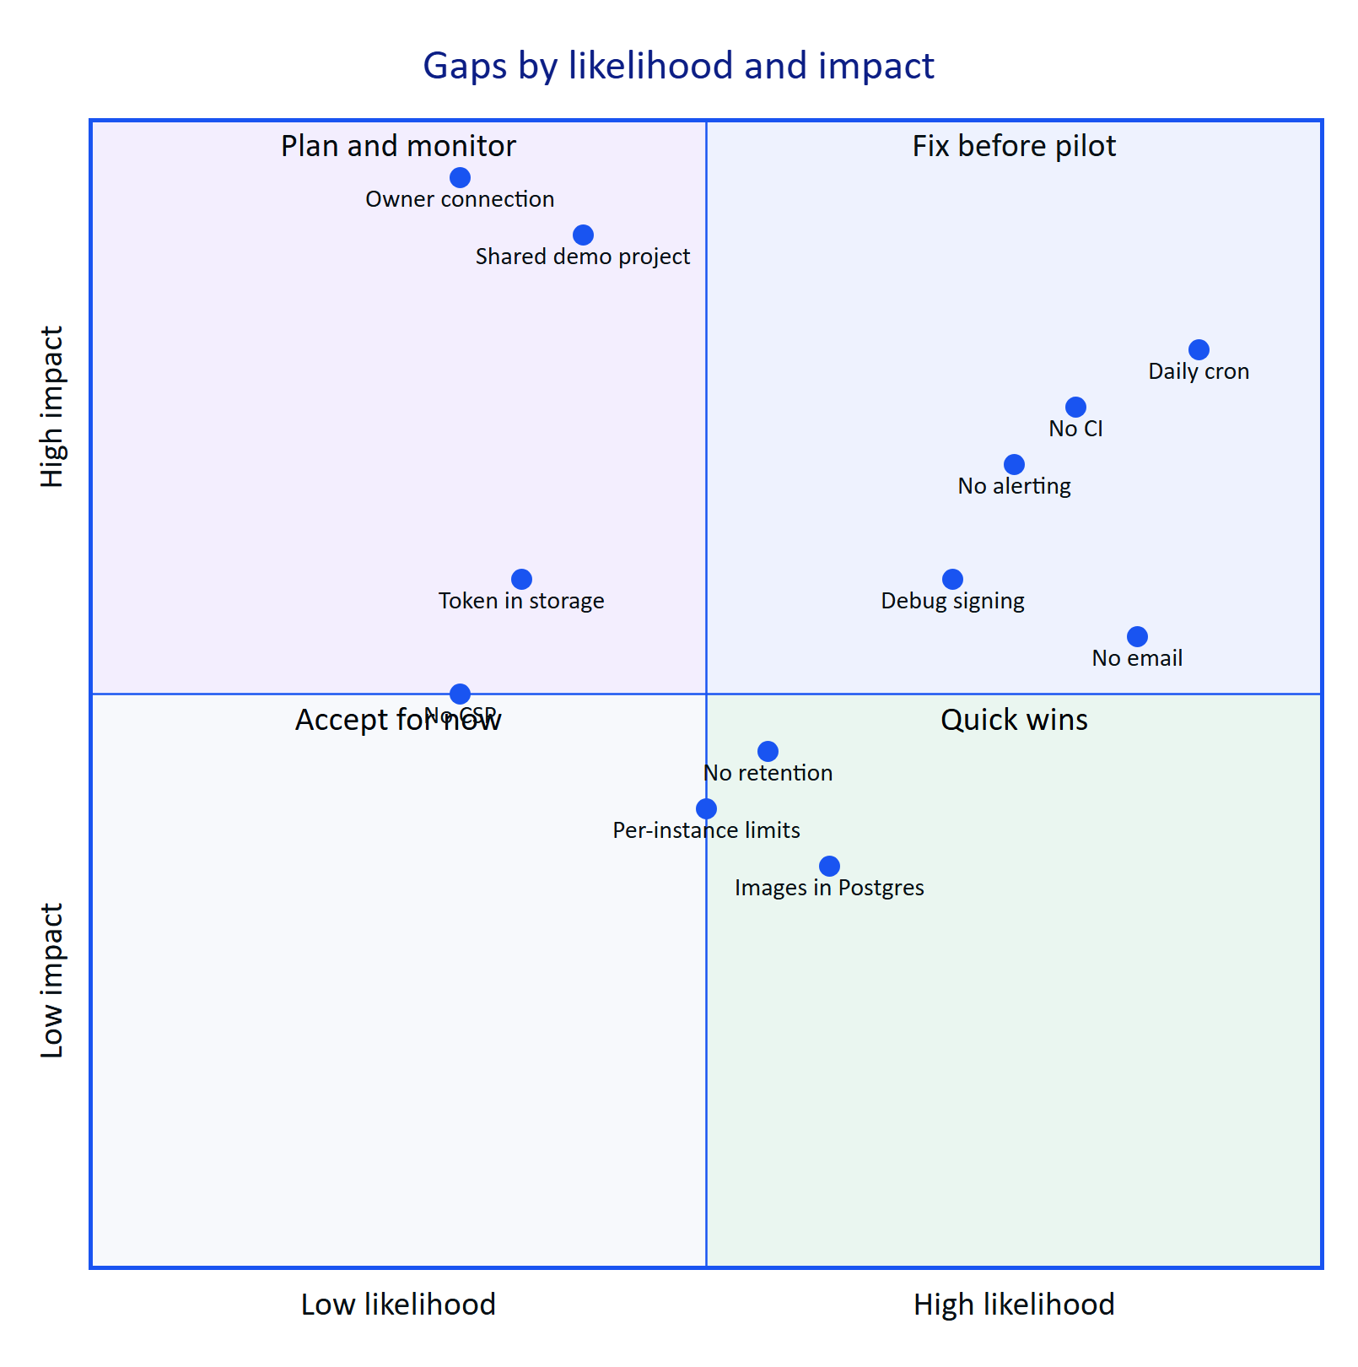
Figure 8. Gap risk quadrant (team assessment, not measured)

